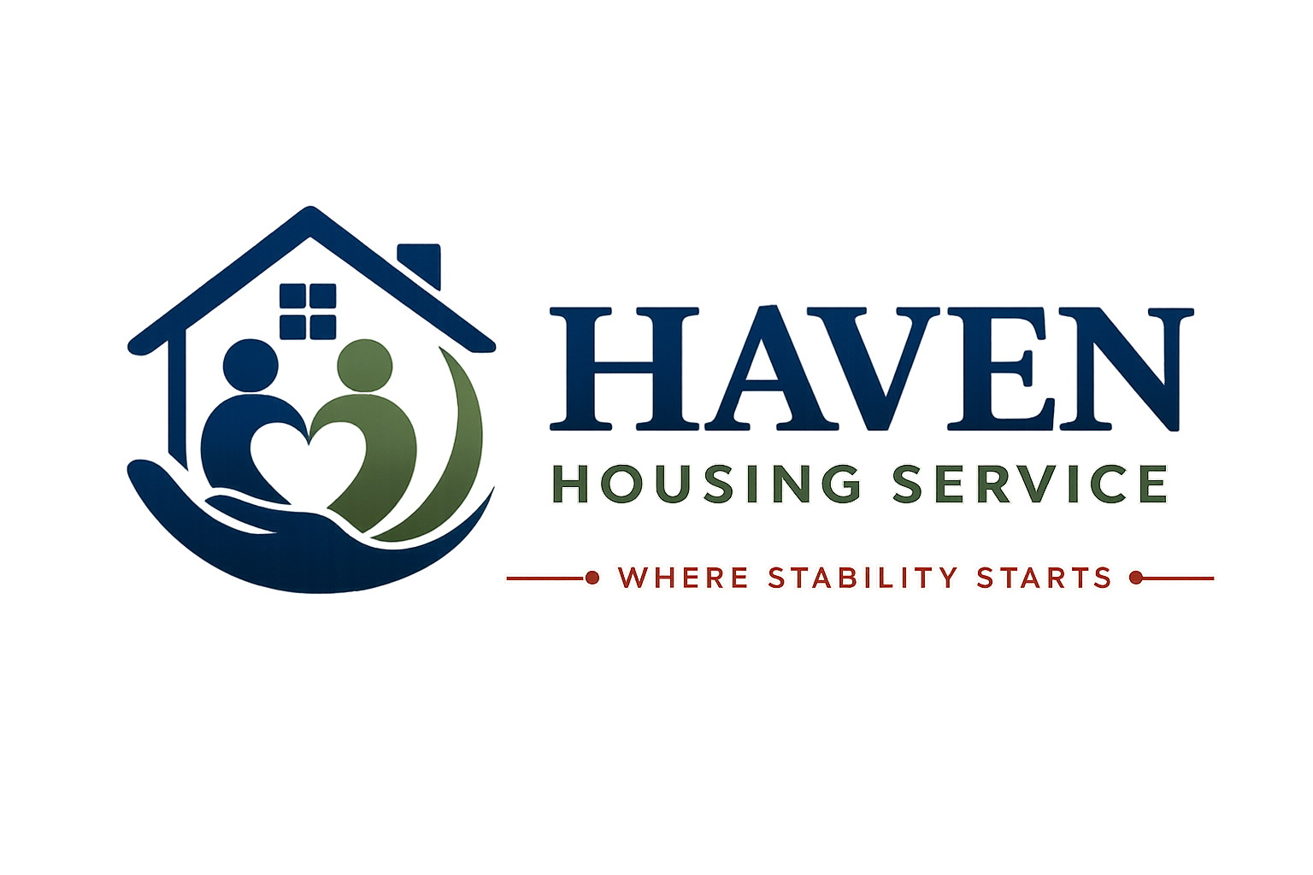

HOUSE RULES
Living well together at Haven Housing Service
Where Stability Starts
Document Title | House Rules
Document Reference | HHS-POL-03
Version | 1.0
Effective Date | [Effective Date]
Next Review Date | [Review Date — 12 months from effective date]
Document Owner | Registered Manager
Classification | Internal / Resident-Facing

Introduction
These House Rules exist to keep everyone at Haven Housing Service safe, respected, and able to live well together. They apply to all residents, and to visitors while on the premises.
Our rules are designed to be fair and proportionate. We understand that everyone's circumstances are different, and our approach to any breach will always consider your individual needs, support plan, and any relevant risk assessment.
A Two-Way Commitment
Just as we ask you to follow these rules, we commit to treating you with respect, listening to your feedback, and applying these rules fairly and consistently.

1. General Conduct
- Treat all staff, residents, neighbours and visitors with courtesy and respect.
- Do not use threatening, abusive, or discriminatory language or behaviour.
- Do not engage in violence or threats of violence towards any person.
- Respect the privacy and personal space of other residents.
- Follow reasonable instructions given by staff regarding safety and conduct.

2. Noise and Consideration for Neighbours
- Keep noise to a reasonable level at all times, and be especially considerate between 10pm and 8am.
- Avoid loud music, television, or gatherings that may disturb other residents or neighbours.
- Repeated noise complaints may result in a formal conversation with your Support Worker.

3. Alcohol, Drugs and Prohibited Items
Haven Housing Service is committed to providing a safe environment. The following rules apply:
- The use, possession, or supply of illegal drugs on the premises is strictly prohibited.
- Excessive alcohol consumption that causes disturbance, risk or harm is not permitted.
- Weapons of any kind are strictly prohibited.
- Smoking is only permitted in designated outdoor areas — never in bedrooms or communal indoor spaces.
- Candles, chip pans, and other fire hazards are not permitted without prior agreement from staff.
Support, Not Just Rules
If you are struggling with drug or alcohol use, please talk to your Support Worker. We can refer you to specialist local services — our aim is always to support you, not simply to enforce a rule.

4. Visitors and Guests
Full detail is provided in our separate Visitors Policy. In summary:
- All visitors must be signed in where a visitors' book is in use.
- Visitors must not stay overnight without prior agreement from staff.
- Residents are responsible for the behaviour of their visitors while on the premises.
- Staff may ask a visitor to leave if their behaviour is unsafe, disruptive, or puts others at risk.

5. Cleanliness and Shared Spaces
- Keep your bedroom in a reasonably clean and tidy condition.
- Clean up after yourself in shared kitchens, bathrooms and lounges.
- Dispose of rubbish appropriately and follow the property's recycling arrangements.
- Do not leave personal belongings in communal areas in a way that blocks access or creates a hazard.
- Report any pest issues to staff immediately.

6. Safety and Security
- Do not prop open external doors or fire doors.
- Do not tamper with smoke alarms, fire extinguishers, or other safety equipment.
- Do not give your key or entry fob to anyone else.
- Report lost keys or fobs to staff immediately.
- Do not let unknown individuals into the building — always check with staff if unsure.

7. Rent and Payments
- Pay rent and any charges on time, as set out in your Licence or Tenancy Agreement.
- Tell your Support Worker immediately if you are struggling to pay — help is available.
- Do not sublet your room or allow anyone else to live there without written agreement.

8. Pets
Pets are not generally permitted at Haven Housing Service properties, in line with tenancy conditions and the needs of shared accommodation. Any exceptions (for example, an assistance dog) must be agreed in writing with the Registered Manager in advance.

9. Property Inspections
We carry out periodic property and room inspections to check health, safety and general condition. Wherever possible, we will give you at least 24 hours' notice, except in an emergency or where there is a serious safety concern.

10. What Happens If Rules Are Broken
We take a graduated, support-focused approach to breaches of House Rules:
- Informal conversation — a chance to discuss the issue and agree next steps.
- Formal verbal warning, recorded in your file.
- Written warning, with a clear action plan.
- Review of your placement, including consideration of a Support Plan or risk management plan update.
- In serious cases — such as violence, dealing drugs, or serious safeguarding risk — formal notice may be given in line with your Licence or Tenancy Agreement.
Fair Process, Always
You will always be told clearly what the concern is, given a chance to respond, and offered support to address it — except where there is an immediate and serious risk to safety.

Acknowledgement of House Rules
I confirm that I have received, read (or had explained to me), and understood the House Rules of Haven Housing Service. I agree to follow these rules during my time as a resident.

 | Name | Signature | Date
Resident
Support Worker / Witness

Contact Haven Housing Service
Address: [Registered Office Address, London] | Tel: [Contact Number] | Email: [Contact Email] | Web: [Website] | Out-of-hours emergency line: [Emergency Number]

