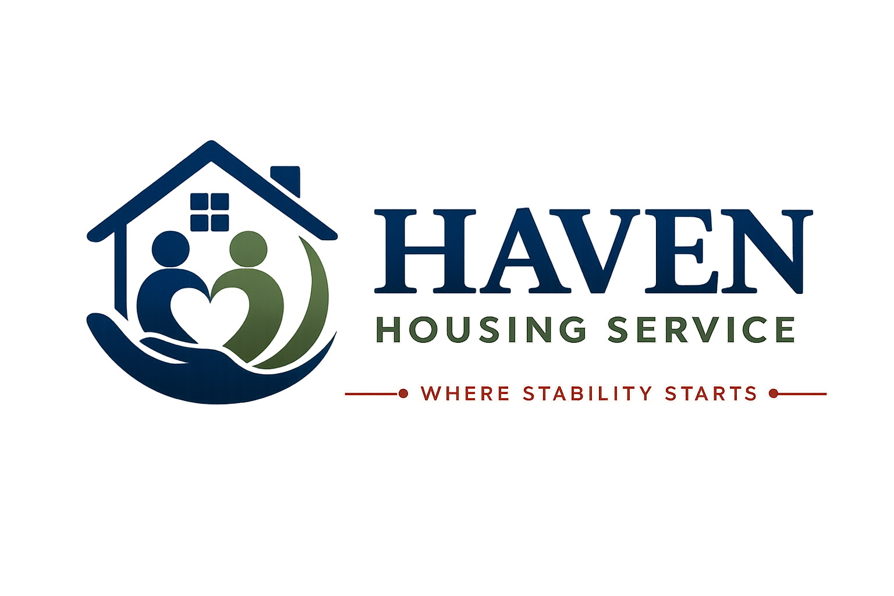

WEBSITE TERMS & CONDITIONS
Terms of use for the Haven Housing Service website
Where Stability Starts
Document Title | Website Terms & Conditions
Document Reference | HHS-POL-18
Version | 1.0
Effective Date | [Effective Date]
Next Review Date | [Review Date — 12 months from effective date]
Document Owner | Registered Manager
Classification | Internal / Resident-Facing

1. Introduction
These Website Terms & Conditions ("Terms") govern your use of the Haven Housing Service website at [Website Address] (the "Website"). By accessing or using our Website, you agree to be bound by these Terms. If you do not agree, please do not use our Website.
Company Name | Haven Housing Service
Registered Office | [Registered Office Address, London]
Company Number | [Company Number]
Contact Email | [Contact Email]

2. Use of Our Website
- You may use our Website for lawful purposes only.
- You must not use our Website in any way that causes damage, impairs availability, or is fraudulent or harmful.
- You must not attempt to gain unauthorised access to our Website, servers, or any connected systems.
- You must not use our Website to transmit or distribute viruses or other malicious code.

3. Intellectual Property
Unless otherwise stated, Haven Housing Service owns the intellectual property rights in the Website and all material published on it, including text, graphics, logos, and design. You may view and print pages from our Website for your own personal, non-commercial use, provided you do not modify any content and you retain any copyright or proprietary notices.
You may not reproduce, republish, or distribute content from our Website for commercial purposes without our prior written permission.

4. Accuracy of Information
We take reasonable care to ensure the information on our Website is accurate and up to date, but we do not guarantee its accuracy, completeness, or timeliness. Information about our services, availability, and eligibility criteria may change, and should be confirmed directly with us before you rely on it — for example, before making a referral or application decision.

5. Links to Other Websites
Our Website may contain links to third-party websites, provided for your convenience. We do not endorse and are not responsible for the content, accuracy, or practices of any third-party website. Accessing linked websites is at your own risk.

6. Enquiries and Submissions
If you submit information to us through our Website (for example, via a contact or referral form), you confirm that the information you provide is accurate. Information submitted through our Website will be handled in line with our Privacy Policy.

7. Limitation of Liability
To the fullest extent permitted by law, Haven Housing Service excludes liability for any loss or damage arising from your use of, or inability to use, our Website, including loss of data, loss of profit, or indirect or consequential loss. Nothing in these Terms excludes or limits our liability for death or personal injury caused by our negligence, or for fraud or fraudulent misrepresentation, or any other liability that cannot be excluded or limited under English law.

8. Website Availability
We do not guarantee that our Website will be available at all times, or free from errors or interruptions. We may suspend, withdraw, or restrict access to all or part of our Website for business or operational reasons, at any time and without notice.

9. Privacy and Cookies
Our use of your personal data is set out in our Privacy Policy, and our use of cookies is set out in our Cookie Policy, both available on our Website.

10. Governing Law
These Terms are governed by and construed in accordance with the laws of England and Wales. Any disputes arising from these Terms or your use of our Website will be subject to the exclusive jurisdiction of the courts of England and Wales.

11. Changes to These Terms
We may update these Terms from time to time. The version number and effective date at the front of this document show when they were last updated. Continued use of our Website following any changes constitutes acceptance of the updated Terms.

12. Contact Us
If you have any questions about these Terms, please contact us.

Contact Haven Housing Service
Address: [Registered Office Address, London] | Tel: [Contact Number] | Email: [Contact Email] | Web: [Website] | Out-of-hours emergency line: [Emergency Number]

Document Approval
Role | Name | Signature | Date
Registered Manager
Operations Director
Safeguarding Lead

