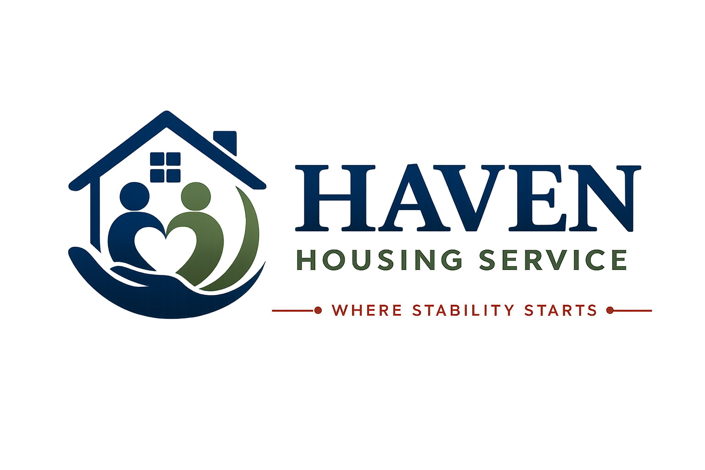

HOUSE RULES
Living well together in shared HMO accommodation at Haven Housing Service
Where Stability Starts
Document Title | House Rules
Document Reference | HHS-POL-03
Version | 2.0
Effective Date | [Effective Date]
Next Review Date | [Review Date — 12 months from effective date]
Document Owner | Registered Manager
Classification | Internal / Resident-Facing

Introduction
You are living in a House in Multiple Occupation (HMO) — a shared property where you have your own bedroom, and share facilities such as the kitchen, bathroom(s), and living areas with other residents. Shared living works best when everyone follows a clear, fair set of rules, so this document is specific to HMO life at Haven Housing Service.
These House Rules apply to all residents and their visitors. They work alongside your Licence Agreement, Resident Handbook, and Resident Responsibilities document.
Regulated Accommodation
This property is managed in line with HMO licensing requirements set by the local authority, including standards for fire safety, amenities, room sizes, and management. A copy of the HMO licence (where applicable) is available on request.

1. Your Room and Shared Spaces

1.1 Your Room
- Your bedroom is your private space. Staff will always give reasonable notice before entering, except in an emergency.
- Keep your room reasonably clean and free of fire hazards and excessive clutter.
- You may personalise your room reasonably (e.g. photos, posters) without causing damage — ask staff before putting up shelving or fixing anything to walls.

1.2 Shared Spaces
- The kitchen, bathroom(s), lounge, hallways and garden (where applicable) are shared by everyone in the house.
- Shared spaces belong to everyone — no single resident can claim exclusive use of a shared area.
- Leave shared spaces as you would want to find them.

2. Kitchen and Food
- Wash, dry and put away your own dishes promptly after use — do not leave washing-up for others.
- Label your food clearly if you keep it in a shared fridge or cupboard. Do not use or take food that isn't yours.
- Clean spills, surfaces, and the hob/oven after cooking.
- Take your rubbish out regularly — do not let it build up in the kitchen.
- Report empty gas canisters, broken appliances, or missing equipment to staff rather than trying to fix them yourself.
- Some properties operate a kitchen cleaning rota — if one is in place at your property, staff will explain how it works and you are expected to take your turn.

3. Bathroom(s)
- Be considerate of others' time — avoid very long showers or baths at busy times (e.g. mornings).
- Clean the bathroom after use, including wiping down surfaces and removing hair from drains.
- Do not leave personal toiletries scattered in shared bathrooms — use your room or an allocated shelf/basket.
- Report leaks, blockages or faults to staff immediately — do not attempt plumbing repairs yourself.

4. Lounge and Communal Living Areas
- Shared TV, games consoles or other equipment (where provided) are for everyone's use — be considerate about volume and viewing time.
- Do not remove shared furniture or equipment from communal areas to your bedroom.
- Clean up after yourself if you eat or drink in shared living areas.
- Be mindful of other residents' need for a calm, comfortable environment — this is often the main space where housemates get to know each other.

5. Noise — Especially Important in Shared Housing
Because bedrooms in an HMO are often close together and share walls, floors or ceilings, noise has a bigger impact than in self-contained housing.
- Keep noise to a minimum between 10pm and 8am — this includes music, TV, phone calls, and conversations in hallways.
- Use headphones for music or videos late at night, or when others may be resting.
- Avoid slamming doors or being heavy-footed on stairs and landings, particularly at night.
- If you have a visitor, keep noise levels appropriate to a shared household at all times, not just at night.

6. Bins and Refuse
- Follow your local council's bin collection days and recycling rules — your Support Worker can confirm these for your property.
- Put rubbish and recycling in the correct bins, not left in communal areas or bin stores incorrectly sorted.
- Take responsibility for your own rubbish — do not leave it for other residents or staff to deal with.

7. Shared Utilities and Energy Use
- Turn off lights, heating and appliances in shared areas when not in use.
- Do not leave taps running unnecessarily.
- Where bills are included in your charges, please still use gas, electricity and water responsibly — excessive use affects the whole household and the sustainability of the service.
- Report any appliance that seems to be using excessive energy or is faulty.

8. Respecting Your Housemates
- Treat every housemate with courtesy and respect, regardless of background, culture, religion, or personal differences.
- Respect differing routines — shift workers, people of faith observing prayer times, or those with support appointments may have different daily patterns.
- Do not enter another resident's bedroom without their invitation.
- Resolve minor disagreements calmly, and ask staff to help mediate if something can't be resolved between housemates directly.

9. Visitors in a Shared House
Full detail is provided in our separate Visitors Policy. In an HMO, the following additional points apply:
- Be considerate of housemates when having visitors in shared spaces — not every housemate will want to socialise with your guests.
- Visitors must not use another resident's belongings, room, or facilities.
- Overnight stays require prior agreement from staff and must not disrupt other residents.
- You are responsible for your visitor's behaviour throughout their time in the shared house.

10. Alcohol, Drugs and Prohibited Items
- The use, possession, or supply of illegal drugs anywhere on the premises, including your own room, is strictly prohibited.
- Excessive alcohol consumption that causes disturbance, risk, or harm to housemates is not permitted.
- Weapons of any kind are strictly prohibited.
- Smoking is only permitted in designated outdoor areas — never in bedrooms, kitchens, bathrooms, or any indoor communal space.
- Candles, chip pans, and portable heaters are not permitted without prior agreement from staff, given the increased fire risk in shared housing.
Support, Not Just Rules
If you are struggling with drug or alcohol use, please talk to your Support Worker. We can refer you to specialist local services — our aim is always to support you, not simply to enforce a rule.

11. Safety and Security in a Shared House
- Do not prop open external doors or fire doors — this is especially dangerous in a shared house with multiple households.
- Do not tamper with smoke alarms, fire extinguishers, or other safety equipment.
- Do not give your key or entry fob to anyone else, including other residents.
- Always lock your bedroom door when you go out, if a lock is fitted.
- Report lost keys or fobs to staff immediately, as this affects the security of the whole household.
- Do not let unknown individuals into the building — always check with staff or other residents if unsure.

12. Rent and Payments
- Pay rent and any charges on time, as set out in your Licence Agreement.
- Tell your Support Worker immediately if you are struggling to pay — help is available.
- Do not sublet your room, or allow anyone else to live there or use it in your absence, without written agreement.

13. Property and Room Inspections
We carry out periodic property and room inspections to check health, safety, fire safety, and general condition, in line with HMO management requirements. Wherever possible, we will give you at least 24 hours' notice, except in an emergency or where there is a serious safety concern.

14. Pets
Pets are not generally permitted in shared HMO accommodation, in line with tenancy conditions and out of consideration for other residents (including allergies and shared space hygiene). Any exceptions (for example, an assistance dog) must be agreed in writing with the Registered Manager in advance.

15. What Happens If Rules Are Broken
We take a graduated, support-focused approach to breaches of House Rules:
- Informal conversation — a chance to discuss the issue and agree next steps.
- Formal verbal warning, recorded in your file.
- Written warning, with a clear action plan.
- Review of your placement, including consideration of a Support Plan or risk management plan update.
- In serious cases — such as violence, dealing drugs, or serious safeguarding risk — formal notice may be given in line with your Licence Agreement.
Fair Process, Always
You will always be told clearly what the concern is, given a chance to respond, and offered support to address it — except where there is an immediate and serious risk to safety.

Acknowledgement of House Rules
I confirm that I have received, read (or had explained to me), and understood the House Rules of Haven Housing Service, including the specific expectations of living in shared HMO accommodation. I agree to follow these rules during my time as a resident.

 | Name | Signature | Date
Resident
Support Worker / Witness

Contact Haven Housing Service
Address: [Registered Office Address, London] | Tel: [Contact Number] | Email: [Contact Email] | Web: [Website] | Out-of-hours emergency line: [Emergency Number]

