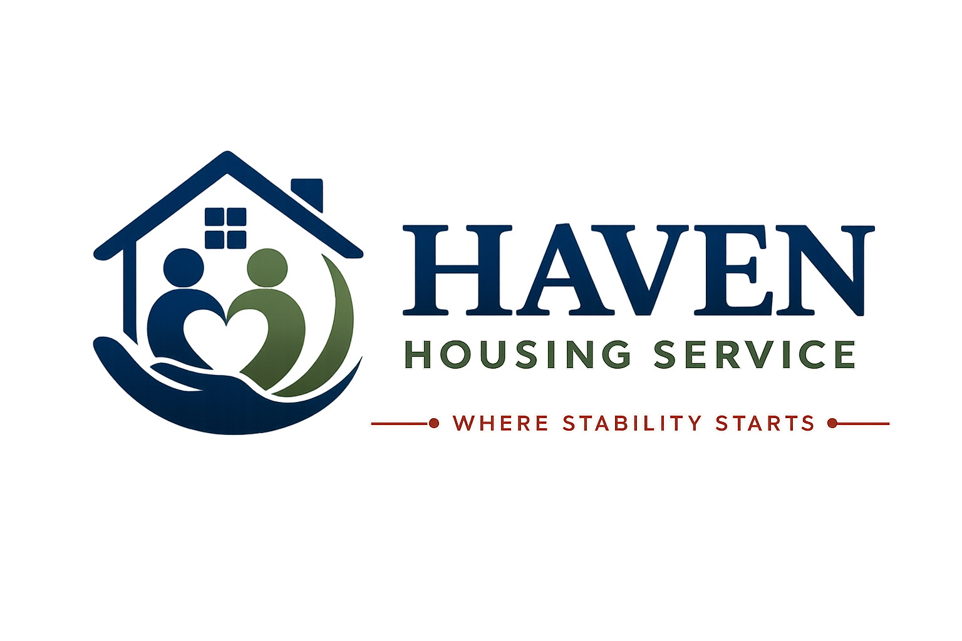

RESIDENT HANDBOOK
Your guide to living in Haven Housing Service accommodation
Where Stability Starts
Document Title | Resident Handbook
Document Reference | HHS-POL-01
Version | 1.0
Effective Date | [Effective Date]
Next Review Date | [Review Date — 12 months from effective date]
Document Owner | Registered Manager / Operations Director
Classification | Internal / Resident-Facing

Contents
1. Welcome to Haven Housing Service
2. Who We Are and What We Do
3. Your Tenancy or Licence Agreement
4. Support Services Available to You
5. Rent, Charges and Money Matters
6. Health and Safety in Your Home
7. Fire Safety
8. Anti-Social Behaviour and House Rules
9. Visitors
10. Repairs and Maintenance
11. Your Rights
12. Your Responsibilities
13. Complaints, Compliments and Feedback
14. Safeguarding — Keeping You Safe
15. Equality, Diversity and Inclusion
16. Data Protection and Your Privacy
17. Moving On — Ending Your Stay
18. Useful Contacts and Emergency Numbers

1. Welcome to Haven Housing Service
Welcome to your new home. This Resident Handbook has been written to help you settle in, understand how Haven Housing Service works, and know what support is available to you. Please take the time to read it carefully and keep it somewhere safe so you can refer back to it.
At Haven Housing Service, everything we do is guided by our values:
- Safe — we provide accommodation and support that protects your wellbeing.
- Professional — our staff are trained, supervised and accountable.
- Compassionate — we treat every resident with kindness and understanding.
- Respectful — we value your dignity, culture and individuality.
- Person-centred — support is built around your needs and goals.
- Independence-focused — we help you build the skills and confidence to move forward.
Our Promise to You
We are committed to helping you find stability, build independence, and move towards a positive future. If at any point you feel this isn't happening, please speak to a member of staff or use our Complaints Procedure (Section 13).

2. Who We Are and What We Do
Haven Housing Service provides safe, supported accommodation across London for people who need somewhere stable to live while they access the support they need. We work with homeless adults, refugees, vulnerable adults, and individuals requiring low-level support.

2.1 Our Accommodation
We manage a number of shared and self-contained properties across London. Each property has a dedicated support worker and a clear set of house rules designed to keep everyone safe.

2.2 Our Staff
You will be introduced to your Support Worker and Registered Manager when you move in. All staff undergo an enhanced DBS check, safeguarding training, and ongoing supervision.

3. Your Tenancy or Licence Agreement
Before you move in, you will be given a Licence Agreement or Tenancy Agreement which sets out the legal terms of your occupation, including your rights and obligations. This handbook does not replace your agreement — where there is any difference between the two, your signed agreement takes priority.

3.1 Occupation Type
Most residents at Haven Housing Service occupy their room or unit under a Licence to Occupy, reflecting the support-led nature of the accommodation. Your Support Worker will explain which type of agreement applies to you and what this means in practice.

3.2 Notice Periods
Notice periods for ending your occupation are set out in your signed agreement. In general:
- You must give the notice period stated in your agreement if you wish to leave.
- We will give you the notice period stated in your agreement, and follow a fair process, if we need to end your occupation.
- In cases of serious risk to you or others, different procedures may apply — these are explained in your agreement.

4. Support Services Available to You
Every resident is allocated a named Support Worker who will complete a Support Plan with you within the first few days of your move-in. Your Support Plan is reviewed regularly and belongs to you — you should always have a copy.

4.1 What Support Looks Like
- Help registering with a GP, dentist and other health services.
- Support with benefits applications and money management.
- Help with education, training, volunteering and employment.
- Life skills support — cooking, budgeting, cleaning, using public transport.
- Emotional and wellbeing support, and signposting to specialist services.
- Support to move towards independent living when you are ready.

4.2 Support Plan Reviews
Your Support Plan will be reviewed with you at least every 4–6 weeks, or sooner if your circumstances change. You are always entitled to bring an advocate, friend or family member to these reviews.

5. Rent, Charges and Money Matters
The rent and any service charges that apply to your room or unit are set out in your Licence Agreement or Tenancy Agreement. Your Support Worker will help you understand what you need to pay, how to pay it, and how to claim any Housing Benefit or Universal Credit housing element you may be entitled to.

5.1 What Your Charges Cover
- Rent for your room or unit.
- Utilities (gas, electricity, water) unless stated otherwise in your agreement.
- Support service charges, where applicable.
- Use of shared facilities (kitchen, bathroom, communal lounge).

5.2 Rent Arrears
If you fall behind with your payments, speak to your Support Worker immediately. We would always rather help you resolve arrears early than let the situation escalate. Free, independent debt advice is available from Citizens Advice and StepChange (see Section 18).

6. Health and Safety in Your Home
We carry out regular health and safety checks on all our properties, including gas safety checks, electrical safety checks (EICR), portable appliance testing (PAT), and legionella risk assessments.

6.1 Your Responsibilities
- Report any repairs, hazards or faults to staff as soon as you notice them.
- Do not tamper with smoke alarms, fire doors or safety equipment.
- Keep your room and shared areas free from trip hazards and excessive clutter.
- Never bring hazardous items (e.g. gas canisters, candles, chip pans) into the property without agreement from staff.

6.2 Our Responsibilities
- Annual gas safety checks (Gas Safe registered engineer).
- Electrical Installation Condition Report every 5 years, or sooner if required.
- Regular fire risk assessments and fire equipment servicing.
- Prompt response to reported repairs (see Section 10).

7. Fire Safety
Fire safety is taken extremely seriously at Haven Housing Service. A full Fire Safety Guide is provided separately and displayed in communal areas. Key points are summarised here.

7.1 On Moving In
- You will be shown the fire evacuation route and assembly point for your property.
- You will be told the location of fire extinguishers, fire blankets and alarm call points.
- Fire drills are carried out at least twice a year — please take these seriously.

7.2 If You Discover a Fire
- Raise the alarm immediately.
- Leave the building by the nearest safe exit — do not stop to collect belongings.
- Close doors behind you where safe to do so.
- Go to the assembly point.
- Call 999 and ask for the Fire Service.
- Do not re-enter the building until told it is safe to do so by the Fire Service.
Important
Never use lifts during a fire evacuation. Never re-enter a building to collect belongings or pets.

8. Anti-Social Behaviour and House Rules
A full copy of our House Rules is provided as a separate document and displayed in your property. Breaches of house rules are handled fairly, proportionately, and with support in mind wherever possible — but repeated or serious breaches may put your occupation at risk.

8.1 Examples of Unacceptable Behaviour
- Violence, threats of violence, or intimidation towards staff, residents or visitors.
- Harassment or discrimination of any kind.
- Supplying or dealing illegal drugs on the premises.
- Causing serious noise nuisance or disturbance to neighbours.
- Deliberate damage to Haven Housing Service or shared property.

8.2 Our Approach
We use a graduated response — informal conversation, written warnings, support planning, and, only where necessary, formal action. Safeguarding concerns are always addressed alongside any behavioural response (see Section 14).

9. Visitors
Residents may generally have visitors in line with the Visitors Policy (provided separately) and their individual risk assessment. Visiting hours, communal area use, and overnight stay rules will be explained to you by your Support Worker.
- All visitors must be signed in where a visitors' book is in use.
- Staff may ask a visitor to leave if their behaviour is unsafe or disruptive.
- Some residents may have specific visitor restrictions as part of a risk management or safeguarding plan — this will be explained to you sensitively and reviewed regularly.

10. Repairs and Maintenance
Please report all repairs promptly. This keeps your home safe and helps us plan our maintenance programme.

How to Report a Repair
- Speak to your Support Worker or property staff directly.
- Call our maintenance line: [Maintenance Contact Number].
- Email: [Maintenance Email Address].

Response Times
- Emergency repairs (e.g. no heating, gas leak, flooding, loss of power): within 24 hours.
- Urgent repairs (e.g. leaking tap, broken lock): within 5 working days.
- Routine repairs: within 20 working days.

11. Your Rights
- To be treated with dignity, respect and without discrimination.
- To a safe, clean and well-maintained home.
- To privacy, subject to the reasonable needs of shared living and safety checks.
- To access your own records, including your Support Plan and personal data.
- To make a complaint without fear of reprisal.
- To advocacy and independent support when making important decisions.

12. Your Responsibilities
A full Resident Responsibilities document is provided separately. In summary, residents are expected to:
- Pay rent and charges on time, or engage with support to manage arrears.
- Treat staff, other residents, neighbours and visitors with respect.
- Engage constructively with your Support Plan.
- Keep your room and shared spaces reasonably clean and safe.
- Follow the House Rules and Fire Safety Guide.
- Report repairs, hazards, and safeguarding concerns promptly.

13. Complaints, Compliments and Feedback
We want to hear from you — whether things have gone well or you feel something needs to improve. Our full Complaints Procedure and Complaints Form are provided as separate documents.

How to Raise a Complaint
- Speak informally to your Support Worker or the Registered Manager — most issues can be resolved this way.
- If unresolved, submit a formal complaint using the Complaints Form, in writing, or by asking a staff member to complete it with you.
- We will acknowledge your complaint within 3 working days and respond in full within 20 working days.
- If you remain unhappy, you can escalate to the Housing Ombudsman Service (details in Section 18).

14. Safeguarding — Keeping You Safe
Everyone has the right to live free from abuse, neglect and exploitation. Our full Safeguarding Policy is available separately and every member of staff is trained to recognise and respond to safeguarding concerns.

Types of Abuse We Look Out For
- Physical, emotional, sexual or financial abuse.
- Neglect or self-neglect.
- Modern slavery, exploitation, or county lines involvement.
- Domestic abuse.
- Discriminatory abuse or hate crime.

How to Raise a Concern
If you are worried about your own safety or that of another resident, tell any member of staff immediately, or contact our Designated Safeguarding Lead on [Safeguarding Contact Number]. In an emergency, always call 999.

15. Equality, Diversity and Inclusion
Haven Housing Service is committed to treating every resident fairly, regardless of age, disability, gender reassignment, marriage or civil partnership, pregnancy or maternity, race, religion or belief, sex, or sexual orientation. Our full Equality & Diversity Policy is available separately.
If you feel you have experienced discrimination, please tell a member of staff or use our Complaints Procedure.

16. Data Protection and Your Privacy
We collect and hold personal information about you in order to provide safe accommodation and effective support. We handle your data in line with UK GDPR and the Data Protection Act 2018. Full details are set out in our Privacy Policy, available separately and on request.
- We only share your information where necessary and lawful — for example with your consent, or where there is a safeguarding duty to do so.
- You have the right to see the information we hold about you.
- You can ask us to correct inaccurate information.

17. Moving On — Ending Your Stay
Our full Moving Out Guide is provided separately. When you are ready to move on — or if your placement is ending — your Support Worker will help you plan the transition, including:
- Notice periods, as set out in your Licence or Tenancy Agreement.
- A Move-On Plan covering housing options, benefits transfer, and support handover.
- A final property inspection and return of keys.
- Return of any deposit, where applicable, in line with your agreement.

18. Useful Contacts and Emergency Numbers
Emergencies
Police / Fire / Ambulance: 999 | Non-emergency Police: 101 | NHS Non-emergency: 111

- Haven Housing Service Main Office: [Contact Number]
- Out-of-Hours Emergency Line: [Emergency Number]
- Designated Safeguarding Lead: [Safeguarding Contact Number]
- Maintenance / Repairs: [Maintenance Contact Number]
- Samaritans: 116 123 (free, 24/7)
- National Domestic Abuse Helpline: 0808 2000 247
- Citizens Advice: 0800 144 8848
- Housing Ombudsman Service: 0300 111 3000

Contact Haven Housing Service
Address: [Registered Office Address, London] | Tel: [Contact Number] | Email: [Contact Email] | Web: [Website] | Out-of-hours emergency line: [Emergency Number]

Document Approval
Role | Name | Signature | Date
Registered Manager
Operations Director
Safeguarding Lead

