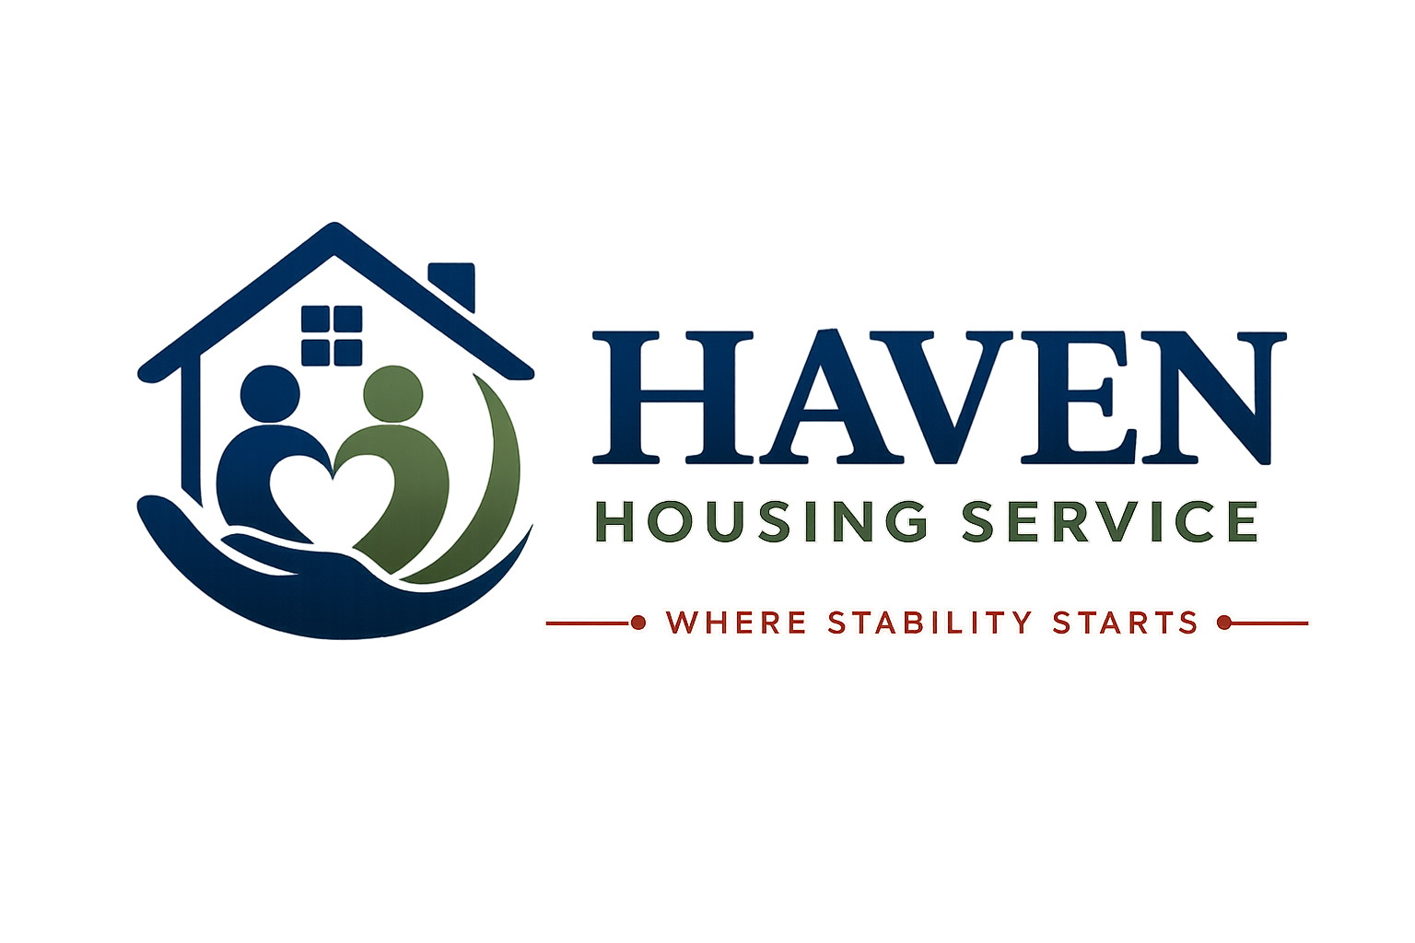

PRIVACY POLICY
How Haven Housing Service collects, uses and protects your personal data
Where Stability Starts
Document Title | Privacy Policy
Document Reference | HHS-POL-16
Version | 1.0
Effective Date | [Effective Date]
Next Review Date | [Review Date — 12 months from effective date]
Document Owner | Registered Manager / Data Protection Lead
Classification | Internal / Resident-Facing

1. Introduction
Haven Housing Service ("we", "us", "our") is committed to protecting your personal data. This Privacy Policy explains what information we collect, why we collect it, how we use it, and your rights under the UK General Data Protection Regulation (UK GDPR) and the Data Protection Act 2018.
Data Controller | Haven Housing Service
Registered Office | [Registered Office Address, London]
Contact Email | [Contact Email]
Data Protection Lead | [Name / Role]

2. What Information We Collect
- Identity information — name, date of birth, gender, nationality, immigration status (where relevant).
- Contact details — address, phone number, email address.
- Support and care information — support needs, risk assessments, Support Plans, case notes.
- Health information — relevant medical information, where shared, to ensure your safety and appropriate support.
- Financial information — benefits information, rent payment records.
- Referral information — from local authorities, health services, or other referring organisations.
- CCTV images, where installed at a property (signposted clearly).
- Information about incidents, complaints, and safeguarding concerns, where applicable.

3. Our Lawful Basis for Processing
We process your personal data under the following lawful bases:
- Contract — to provide accommodation and support services under your Licence or Tenancy Agreement.
- Legal obligation — to comply with housing, health and safety, and safeguarding law.
- Vital interests — to protect your life or the life of another person in an emergency.
- Legitimate interests — to run our organisation effectively, including monitoring service quality.
- Consent — for specific purposes where required, which you can withdraw at any time.
Where we process special category data (such as health information, or information about racial or ethnic origin), we rely on Article 9 conditions, including the provision of health or social care, and substantial public interest for safeguarding purposes.

4. How We Use Your Information
- To provide safe accommodation and appropriate support.
- To manage your tenancy or licence, including rent and charges.
- To keep you safe, including responding to safeguarding concerns.
- To communicate with relevant professionals involved in your care or support.
- To comply with legal and regulatory requirements.
- To monitor and improve the quality of our services.

5. Sharing Your Information
We only share your information where necessary and lawful, including with:
- Local authorities and commissioning bodies who fund or oversee your placement.
- Health and social care professionals involved in your support.
- Emergency services, where necessary for your safety or the safety of others.
- Regulatory bodies, such as the Regulator of Social Housing, CQC (where applicable), or the Housing Ombudsman Service.
- Professional advisors, such as our solicitors, auditors, or insurers.
We do not sell your personal data. We do not share your information with third parties for marketing purposes.

6. How Long We Keep Your Information
We retain personal data only for as long as necessary for the purposes it was collected, and in line with legal requirements. As a general guide:
Tenancy/Licence records | 6 years after the end of occupation
Support and care records | 6–7 years after the end of support, or longer where required by safeguarding law
Financial records | 6 years, in line with HMRC requirements
CCTV footage | Typically 30 days, unless required for an investigation

7. Your Rights
Under UK GDPR, you have the right to:
- Access the personal data we hold about you (Subject Access Request).
- Request correction of inaccurate personal data.
- Request erasure of your personal data, in certain circumstances.
- Restrict or object to certain processing of your data.
- Request data portability, where applicable.
- Withdraw consent, where processing is based on consent.
- Lodge a complaint with the Information Commissioner's Office (ICO).
To exercise any of these rights, please contact us using the details at the end of this policy.

8. Keeping Your Information Secure
- Personal data is stored on secure, access-controlled systems.
- Paper records are kept in locked storage.
- Staff receive data protection training and access data on a need-to-know basis.
- We have procedures in place to detect, report and respond to any data breach.

9. International Transfers
We do not routinely transfer personal data outside the UK. If this ever becomes necessary, we will ensure appropriate safeguards are in place in line with UK GDPR requirements.

10. How to Complain
If you are unhappy with how we have handled your personal data, please contact us first so we can try to resolve your concern. You also have the right to complain directly to the Information Commissioner's Office (ICO):
ICO Helpline | 0303 123 1113
Website | www.ico.org.uk
Address | Wycliffe House, Water Lane, Wilmslow, Cheshire, SK9 5AF

11. Changes to This Policy
We may update this Privacy Policy from time to time. The version number and effective date at the front of this document show when it was last updated. Significant changes will be communicated to residents directly.

Document Approval
Role | Name | Signature | Date
Registered Manager
Operations Director
Safeguarding Lead

Contact Haven Housing Service
Address: [Registered Office Address, London] | Tel: [Contact Number] | Email: [Contact Email] | Web: [Website] | Out-of-hours emergency line: [Emergency Number]

