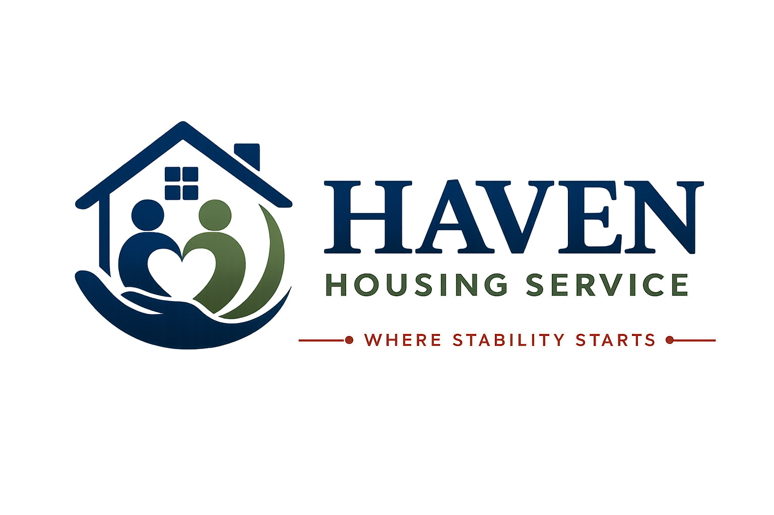

HEALTH & SAFETY GUIDE
Keeping your home and environment safe
Where Stability Starts
Document Title | Health & Safety Guide
Document Reference | HHS-POL-08
Version | 1.0
Effective Date | [Effective Date]
Next Review Date | [Review Date — 12 months from effective date]
Document Owner | Registered Manager / Health & Safety Lead
Classification | Internal / Resident-Facing

Introduction
Haven Housing Service is committed to providing a safe environment for residents, staff and visitors, in line with the Health and Safety at Work etc. Act 1974 and associated regulations. This guide explains how we manage health and safety, and what is expected of you as a resident.

1. Our Health and Safety Commitments
- Annual gas safety checks by a Gas Safe registered engineer.
- Electrical Installation Condition Reports (EICR) at least every 5 years.
- Portable Appliance Testing (PAT) for shared electrical equipment.
- Legionella risk assessments and water safety checks.
- Regular health and safety inspections of all properties.
- Risk assessments for individual residents where needed.
- Staff training in health and safety, first aid, and safe working practices.

2. Gas and Electrical Safety

2.1 Gas Safety
- All gas appliances are checked annually by a Gas Safe registered engineer.
- A copy of the current Gas Safety Certificate is available on request.
- Report any smell of gas immediately — leave the building, avoid using switches or naked flames, and call the National Gas Emergency Number: 0800 111 999.

2.2 Electrical Safety
- Do not overload sockets or use multi-adaptors excessively.
- Do not use any electrical item with a damaged cable or plug.
- Report faulty sockets, switches or wiring to staff immediately.
- Personal electrical items you bring into the property may be subject to a visual safety check.

3. Hygiene and Water Safety
- Run taps and showers that are used infrequently for at least two minutes to reduce the risk of Legionella.
- Report any unusual water discolouration, smell, or reduced water pressure to staff.
- Follow good hygiene practices in shared kitchens and bathrooms.
- Store and prepare food safely — clean surfaces, check use-by dates, and store raw and cooked food separately.

4. Reporting Hazards
If you notice anything that could be a health and safety hazard — however small — please report it to staff as soon as possible.
☐ | Trip or slip hazards (loose carpet, spills, clutter in walkways)
☐ | Damaged furniture or fixtures
☐ | Faulty electrical sockets, switches, or appliances
☐ | Signs of damp, mould, or leaks
☐ | Blocked fire exits or escape routes
☐ | Pest sightings
☐ | Broken locks, windows, or doors

5. Accidents and Incidents
If you are involved in or witness an accident or incident, please tell staff as soon as possible so it can be recorded and, where necessary, investigated. A separate Incident Report Form is used to record details.
- Minor injuries: report to staff and access first aid if needed.
- Serious injuries: call 999 immediately, then inform staff.
- Near misses (where something could have caused harm but didn't) should also be reported — they help us prevent future accidents.

6. Hazardous Substances (COSHH)
Cleaning products and other substances that could be harmful are stored securely and used in line with the Control of Substances Hazardous to Health Regulations (COSHH). Please:
- Never mix cleaning chemicals together.
- Store any hazardous substances you bring into the property safely, out of reach of anyone at risk.
- Ask staff if you're unsure how to safely use a cleaning product provided by us.

7. Personal Safety and Wellbeing
- Lock your bedroom door when you are out, if a lock is provided.
- Do not let unknown individuals into the building.
- Let staff know if you feel unsafe for any reason.
- If you have specific health needs (for example, mobility needs, allergies, or a condition that could affect your safety), please make sure your Support Worker is aware so this can be reflected in your risk assessment.

8. Risk Assessments
We carry out risk assessments at property level and, where relevant, for individual residents. These are reviewed regularly and whenever circumstances change. You are entitled to see and discuss any risk assessment that relates to you.
Last Property Risk Assessment | [To be completed by staff]
Next Property Risk Assessment Due | [To be completed by staff]
Last Gas Safety Check | [To be completed by staff]
Last Electrical Safety Check (EICR) | [To be completed by staff]

Acknowledgement of Health & Safety Guide
I confirm that I have received and understood this Health & Safety Guide, and I understand how to report a hazard, accident, or incident.

 | Name | Signature | Date
Resident
Support Worker / Witness

Contact Haven Housing Service
Address: [Registered Office Address, London] | Tel: [Contact Number] | Email: [Contact Email] | Web: [Website] | Out-of-hours emergency line: [Emergency Number]

